9/23/19
Migration Update_Customer_External_HP

Welcome to Aetna Medicare Rx offered by SilverScript!
Effective January 1, 2020, Aetna’s Medicare Prescription Drug Plan will migrate to the SilverScript administrative platform. The plan will now be called Aetna Medicare Rx offered by SilverScript. The following information will help explain this transition.

Member Communication Timeline
- October – Announcement letter
- December – Members will begin to receive 2020 plan materials

Timing | Items Included
October (mid to end of month) | October Announcement letter  - Mailed by Aetna to all PDP members
December | ID Card/Confirmation Letter (First Class Mail)  Includes:  - Confirmation of Enrollment  - ID Card  - LIS Rider (if applicable)
December | Welcome Kit (Standard Mail)  Includes:  - Welcome Kit Insert  - Abridged Formulary  - Pharmacy Directory  - Evidence of Coverage  - Mail Order Form

October Announcement
- This is the first time members will be informed about the change to their PDP for 1/1/20
- This customer- and benefits-specific letter is being mailed in late October, when the renewing members typically would have received their Annual Notice of Change
- The letter will explain the communications that will be received later in the year (EOC/Welcome Kit, ID card, etc.)

CMS-Required Member Mailings
ID Card and Confirmation Letter

In December (depending upon when the eligibility is loaded into the new platform), members will receive their new 2020 ID Card with Confirmation letter. It is mailed at the same time as the Welcome Kit, however this is mailed first class to ensure members receive it timely and do not misplace it amongst the larger packet of plan materials. This mailing includes:

- ID Card for the Aetna Medicare Rx offered by SilverScript prescription drug plan
- Confirmation Letter – this confirms the member’s move into the Aetna Medicare Rx offered by SilverScript prescription drug plan by CMS
- LIS Rider – only included if the member has Low Income Subsidy or “Extra Help”

Sample ID Card
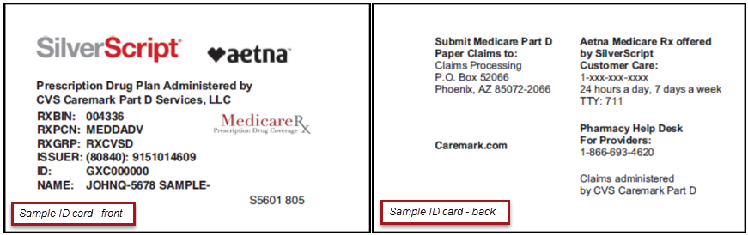

Welcome Kit
In mid-to late December, members will receive the Evidence of Coverage and Welcome Kit. This mailing includes:
- Welcome Kit Insert – this is a custom piece, specific to our migrating members that will include a year-over-year change grid, similar to the Annual Notice of Change that renewing members are accustomed to receiving
- Abridged Formulary (List of Covered Drugs) – the list of commonly used drugs covered under by the plan. Note: members will receive an abridged, or shortened, formulary guide in their Welcome Kit for 2020. The full, comprehensive formulary guide will be available online at aetnaretireeplans.com.
- Pharmacy Directory – the list of network pharmacies in the member’s area, including preferred network pharmacies, if included in the plan
- Evidence of Coverage – details about the plan and member’s rights and responsibilities
- Mail Order Form – for use by members that are not already using the CVS Caremark Mail Service Pharmacy

In-Home Timeline (as of 09/24/19)
- Final dates subject to change
Wave | Mail By Date | ID Card  In-Home | Welcome Kit  In-Home Late
WAVE 1- 11/17/2019 | 11/30/19 | Early: 12/03/19  Late: 12/05/19 | Early: 12/07/19  Late: 12/10/19
WAVE 2- 11/24/2019 | 12/07/19 | Early: 12/10/19  Late: 12/12/19 | Early: 12/14/19  Late: 12/17/19

What changes will the member experience?

As a member of Aetna Medicare Rx offered by SilverScript, there may be some changes in 2020 to the plan’s costs and benefits; the majority of these changes will be similar to what members have previously experienced when moving from one plan year to the next (such as formulary pharmacy network changes). Additionally, members will experience the following administrative changes.

 | 2019 | 2020
Our website | Primary website address was AetnaRetireePlans.com | This year your primary website address is Caremark.com. After December 1, 2019 you can register to access your personalized account and plan information.
Pharmacy search | Pharmacy search website was AetnaMedicare.com/findpharmacy
Formulary/covered drug search | The formulary lookup website was AetnaRetireePlans.com
Secure member portal | The secure member portal was AetnaNavigator.com. You can still access your 2019 information using Aetna Navigator.
Comprehensive formulary guides (PDFs) | PDFs of the formularies are available at aetnaretireeplans.com | PDFs of the formularies are available at aetnaretireeplans.com
Claim submission address | Aetna Pharmacy Management  P.O. Box 52446  Phoenix, AZ 85072-2446 | SilverScript Insurance Company  Prescription Drug Plans  Medicare Part D Paper Claim  P.O. Box 52066  Phoenix, AZ 85072-2066
Customer Care Hours | 24 hours a day, 7 days a week | 24 hours a day, 7 days a week

Key points to know
- SilverScript is a Medicare Prescription Drug Plan (PDP) owned by CVS Health. As Aetna is also owned by CVS Health, we are integrating our plans with SilverScript.
- There will be no interruption in coverage as members are transferred from the current prescription drug plan to the Aetna Medicare Rx offered by SilverScript plan.
- Enrollment/Eligibility
  - Most members will be automatically enrolled in the new 2020 Aetna Medicare Rx offered by SilverScript plan
  - Some Employer Groups require their members to enroll during Open enrollment to elect the plan the member wants for the 2020 plan year.
- Members are encouraged to:
  - Carefully review the Abridged Formulary to determine if any medications will have changes in coverage. If they do not find their drug on the Abridged Formulary document, they can check coverage on Caremark.com (after 1/1/20) or by calling Customer Care at the number provided. The comprehensive formulary will be available online at aetnaretireeplans.com, or members can call customer service for assistance.
  - Open and read any information received from Aetna Medicare Rx offered by SilverScript.
- Members that currently use the CVS Caremark Mail Service Pharmacy for prescriptions may continue to do so. Members will not need to contact us to move any remaining refills to the new plan.
- Prior authorizations with an expiration later than 12/31/19 will move with the member to Aetna Medicare Rx offered by SilverScript.
- Members may begin to fill prescriptions using the new ID card starting on January 1st, 2020.
  - If the ID card has not been received, or has been misplaced after receipt, members can contact us at the number on the back of the Evidence of Coverage
- Members may provide the following information to the pharmacy, however, the pharmacy staff may need to call the pharmacy help desk to obtain the Member ID number

Pharmacy Billing Information
RXBIN | RXPCN | RXGROUP
004336 | MEDDADV | RXCVSD

New Member Service numbers:
Members should continue to use the phone number on their ID card through the end of 2019.

The number below will not be live until November 15th, 2019. This phone number should not be shared with members until after this date.

Also, if the member eligibility is not loaded by November 15th, the call center reps will not be able to address the member’s calls until eligibility and benefits are available.

Description | Post Go-Live Greeting | Member TFN
Aetna SSI Harvard Pilgrim | " Thank you for calling Aetna Medicare Rx, offered by SilverScript, a CVS company serving Harvard Pilgrim Medicare members" | 855-334-5057

Billing Changes:
- Will be provided soon

Contract Addendums:
- All customers that use a standard agreement will receive written notice that the contract is being assigned to SilverScript Insurance Company as of 1/1/20.

You, and your members, remain our top priority. We are committed to continue delivering the products, support and services you expect from us.

